23rd January 2019

**YOKOHAMA Tyres Coming Factory-Equipped on Mercedes-AMG’s E-Class 53-series**

YOKOHAMA announced today that Mercedes-AMG has selected YOKOHAMA's global flagship “ADVAN Sport V105” tyres as original equipment for its new E 53 4MATIC+ (ISG installed) series, which includes sedan, station wagon, coupe and cabriolet models. YOKOHAMA began supplying the tyres in June 2018 in two size sets – the19-inch set includes 245/40ZR19 (98Y) front tyres and 275/35ZR19 (100Y) rear tyres, and the 20-inch set includes 245/35ZR20 (95Y) front tyres and 275/30ZR20 (97Y) rear tyres. The new E-Class 53-series was launched worldwide in summer 2018 and announced in Japan in September 2018.  
  
The “ADVAN Sport V105” is a high-performance tyre developed by YOKOHAMA primarily for use on high-power premium automobiles. The tyre delivers excellent driving performance combined with superior comfort and safety characteristics. The tyres being supplied to Mercedes-AMG were jointly developed and bear the automaker’s “MO” mark of approval on the tyre sidewall.   
  
Under its three-year medium-term management plan, GD2020, launched in February 2018, YOKOHAMA has positioned the expansion of its presence in the premium tyre markets as the core goal for its consumer tyre business. One of the specific strategies for achieving that goal is the “premium-car tyre strategy”, which aims to increase use of YOKOHAMA tyres as OE on premium cars in Japan and abroad by making YOKOHAMA the tyre maker chosen by automakers around the world in recognition of its technologies and quality.

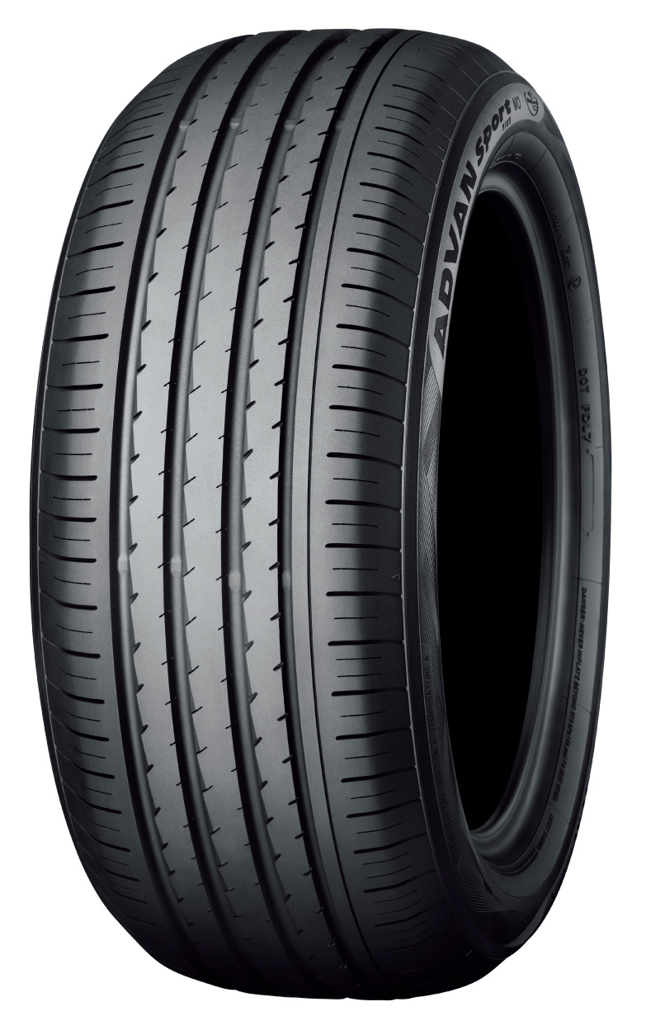

*The “ADVAN Sport V105” Tyre shown in photo differs in size from those installed on the new E-Class 53-series*

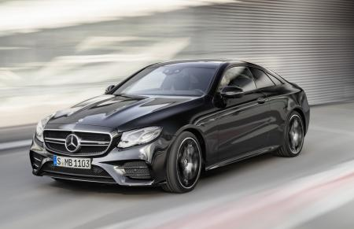

*“New E-Class Coupe” The above photo is used with the permission of Mercedes-AMG. Reprint or other usage of this image without prior permission from Mercedes-AMG is strictly prohibited.*